Hibernate caching improves the performance of the application by pooling the object in the cache. It is useful when we have to fetch the same data multiple times.

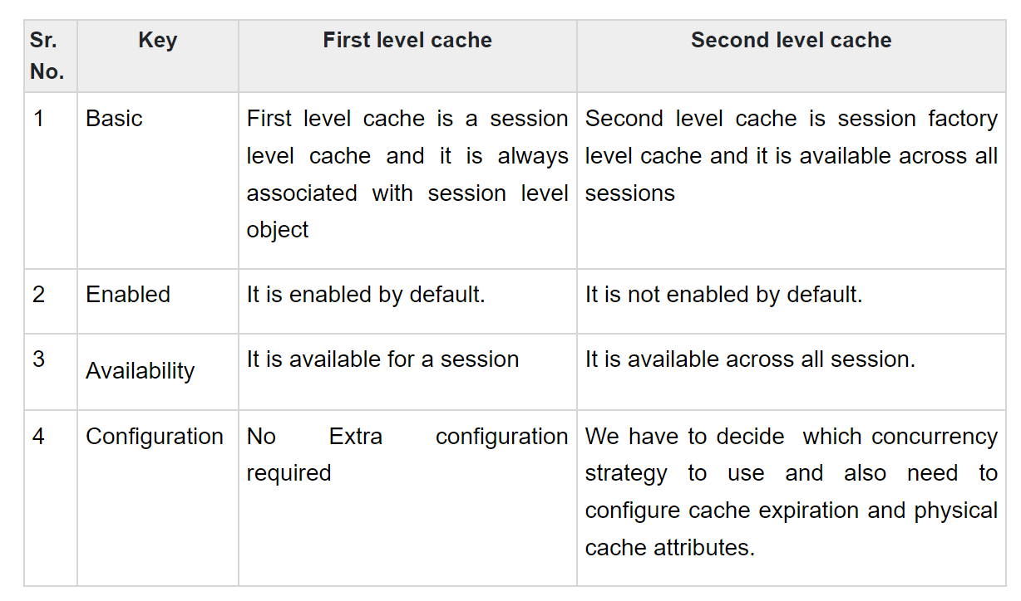

Example of second level cache :

EH (Easy Hibernate) Cache